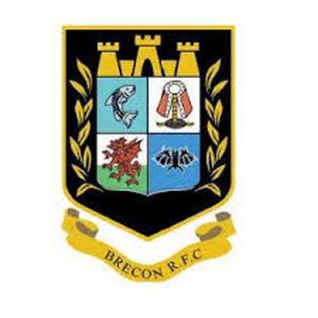

Brecon RFC, Austin Jones Triple Open Cup Competition

28th July 2019 9am – 9:30am

£15 per Team add a spare member for an extra £5

Entry Form
Registration from 9:00 to 9:30, The first 32 teams to enter will be placed into competition, any other bookings after will be notified
Any problems give Gareth a call on 07811703585 or leave a text

This form can be printed and posted or either emailed to Breconrfcboulesclub@outlook.com or contact us through our website on breconrfcboulesclub.weebly.com
Post to:
Gareth Smart
1 Brynawelon
Brecon
Powys
LD3 7PP
Team name
Player 1 - Team captain
Player 2
Player 3
Player 4 – Spare Player
email Address
Home Contact number
Mobile Contact Number
Payment made Official Use Only

Our Location is as follows:
Brecon Rugby club, 63 Watton, Brecon LD3 7EL
